Lancashire Adult Learning South and East Area
Jupiter House, Mercury Rise, Syke Side Drive, Altham Business Park, Accrington, Lancs, BB5 5YE

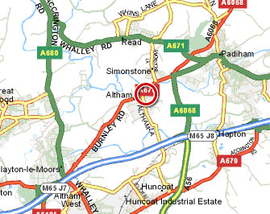

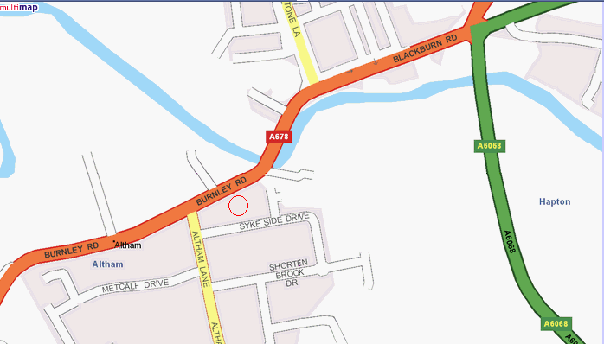

M65 (Blackburn/Burnley/Nelson/Colne)
- Travel East (from Blackburn) or West (from Burnley/Nelson/Colne) to J8.
- Leave the motorway at J8 and take the A6068 towards Clitheroe.
- Continue down the hill until you reach the traffic lights at the junction with the A678.
- Turn left at the junction and follow the A678 in the direction of Accrington/Clayton-le-Moors.
- Pass Simonstone Business Park on the right.
- Continue along the A678 until you reach the Walton Arms pub on the right.
- Turn left at the mini roundabout off the A678 (opposite the pub) on to Altham Ind. Estate/Bus. Park.
- Take the first major road – Syke Side Drive - on the left.
- Take the 2nd left (after ‘Walton House’) into Mercury Rise.
- East Lancashire Adult Learning’s premises are the last unit of ‘Jupiter House’ on the left hand-side

M62/M66 (Manchester/Leeds)
- Travel East (from Manchester) or West (from Leeds) along the M62 to J18.
- Leave the motorway at J18 and take the M66 North towards Bury/Burnley.
- Follow the M66 until it becomes the A56, (the A56 bears off left just after termination of the motorway) and continue to follow the signs for the M65.
- The A56 meets the M65 at J8.
- At J8 of the M65 take the A6068 towards Clitheroe.
- Continue down the hill until you reach the traffic lights at the junction with the A678.
- Turn left at the junction and follow the A678 in the direction of Accrington/Clayton-le-Moors.
- Pass Simonstone Business Park on the right.
- Continue along the A678 until you reach the Walton Arms pub on the right.
- Turn left at the mini roundabout off the A678 (opposite the pub) on to Altham Ind. Estate/Bus. Park.
- Take the first road – Syke Side Drive - on the left.
- Take the 2nd left (after ‘Walton House’) into Mercury Rise.
- East Lancashire Adult Learning’s premises are the last unit of ‘Jupiter House’ on the left hand-side

Car Parking

Please use the car park which is immediately to your left on turning into Mercury Rise. If this is full, please park on Syke Side Drive, where there is unrestricted, on-road parking. Disabled Parking is available at the front of the building.

